**KING’S OWN INSTITUTE\***

**Success in Higher Education**

**GROUP ASSIGNMENT COVER SHEET**

Subject Code & Name: **ICT203 Human Computer Interaction T225**

Lecturer’s/Tutor’s name: **Mr. Noman Haider**

Assignment Title: **Assessment4 :Group Project Report**

**Declaration**

(This declaration must be completed by all students in the group, or the assignment will not be marked.)

We, the undersigned, certify the following:

* We have read and understood the *Student Academic Misconduct Policy*
* This assignment is our own work based on our personal study and or research.
* We have acknowledged all material and sources used in the preparation of this assignment including any material generated in the course of our employment.
* **The assignment has not previously been submitted for assessment in this or any other unit.**
* We have not copied in part or in whole or otherwise plagiarised the work of other students.
* We have read and understand the criteria used for assessment.
* The assignment is within the word and page limits specified in the unit outline.
* The use of any material in this assignment does not infringe the intellectual property / copyright of a third party.
* We understand that this assignment may undergo electronic detection for plagiarism, and an anonymous copy of the assignment may be retained on the database and used to make comparisons with other assignments in future.
* By completing this coversheet in full and submitting this assignment electronically, we are bound by the conditions of the KOI's *Student Academic Misconduct Policy* and the declaration on this coversheet.

|  |  |  |  |  |  |
| --- | --- | --- | --- | --- | --- |
|  | Family Name | Given Name(s) | Student ID | Tutorial/ Code | Signature |
| Student 1 | JAISWAL | Bikash | 20029098 | ICT203 | Bikash |
| Student 2 | Togasaki | Masahiro | 20027985 | ICT203 | Masahiro |
| Student 3 | Mailom Arcebuche | Joseph Neil | 20029531 | ICT203 | Joseph Neil |
| Student 4 | Hieu VO | Thanh | 20031054 | ICT203 | Thanh |
| Student 5 | THAPA KSHETRI | Deepika | 12301540 | ICT203 | Deepika |



**Assignment Receipt**

Subject Code & Name: Lecturer’s/Tutor’s Name: Assignment Title:

|  |  |  |  |  |  |
| --- | --- | --- | --- | --- | --- |
|  | Family Name | Given Name(s) | Student ID | Tutorial/ Code | Signature |
| Student 1 |  |  |  |  |  |
| Student 2 |  |  |  |  |  |
| Student 3 |  |  |  |  |  |
| Student 4 |  |  |  |  |  |
| Student 5 |  |  |  |  |  |

**Title: Assessment 4: Group Project**

**Case Study: Kids Code Library**

**Table of Contents**

1. Introduction 1

2. Detailed Design of the Webpages 1

**2.1 Simplicity of Contents (Home)** 1

**2.2 Easy to Learn (Learn to Code)** 1

**2.3 Interesting Activities (Gamified Activities)** 1

**2.4 Various Resources (Learning Resources)** 1

**2.5 Easy to Contact (Home)** 1

3 Prototype Development 1

**3.1 Strive for Consistency** 1

**3.2 Enable frequent users to use shortcuts** 2

**3.3 Offer Informative Feedback** 2

**3.4 Design Dialogue to Yield Closure** 2

**3.5 Offer Simple Error Handling** 2

**3.6 Permit Easy Reversal of Actions** 2

**3.7 Support Internal Locus of Control** 2

**3.8 Reduce Short Term Memory Load** 2

4. Testing of the Website with Screenshots 2

5. Conclusion 3

6. Recommendations 3

7. Reference 3

8. Group Activity Log 3

# **1. Introduction**

Graphics sources:

# **2. Detailed Design of the Webpages**

## **2.1 Simplicity of Contents (Home)**

The design for kids Code library website focuses on developing an engaging and

## **2.2 Easy to Learn (Learn to Code)**

The design for kids Code library website focuses on developing an engaging and

## **2.3 Interesting Activities (Gamified Activities)**

The design for kids Code library website focuses on developing an engaging and

## **2.4 Various Resources (Learning Resources)**

The design for kids Code library website focuses on developing an engaging and

## **2.5 Easy to Contact (Home)**

The design for kids Code library website focuses on developing an engaging and

# **3 Prototype Development**

A sitemap is a file where you provide information about the pages, videos, and other files on your site, and the relationships between them. (Google Developers, 2024)

## **3.1 Strive for Consistency**

Consistency is essential for a good user interface. Shneiderman et al. indicate that strive for consistency means keeping design components uniform such as fonts, colours, and actions (2017, pp.95).

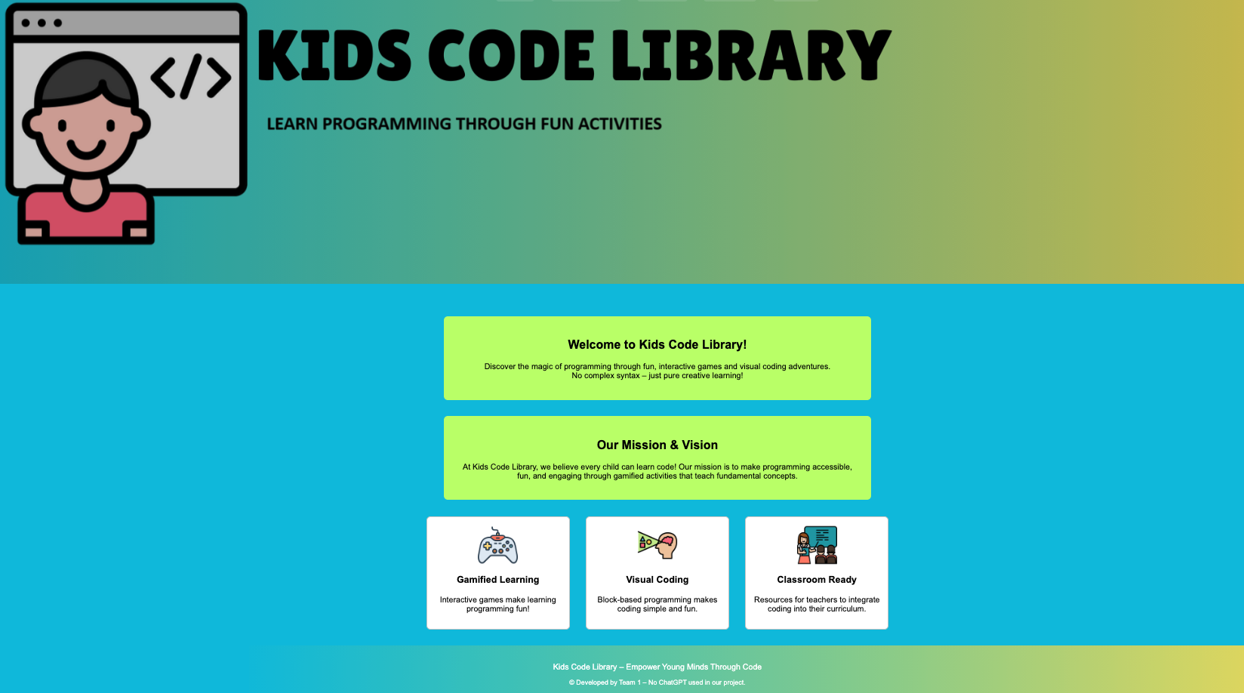

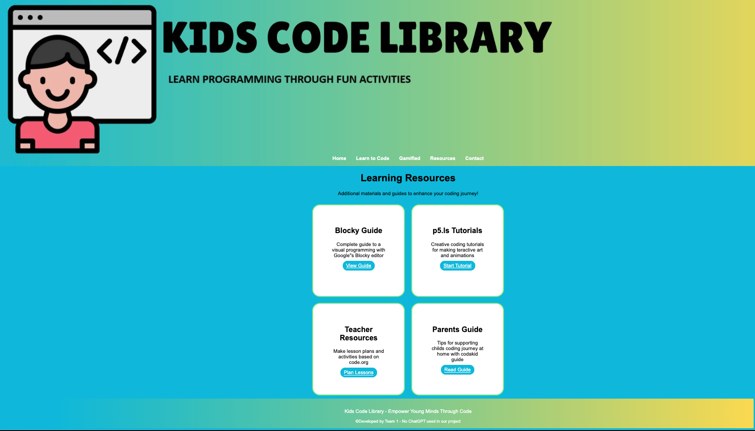

In the above diagrams, the home page and resources page of Kids Code Library are used. The #0cc0df is the colour code which is used for background colour of the body throughout the website. Also, the entire website uses the Arial, sans-serif font family. Each page has an option with same navigation bars of Home, Learn to Code, Gamified, and Resources followed by Contact. All these points prove that Kids Code Library website has an integrated design.

## **3.2 Enable frequent users to use shortcuts**

A sitemap is a file where you provide information about the pages, videos, and other

## **3.3 Offer Informative Feedback**

A sitemap is a file where you provide information about the pages, videos, and other

## **3.4 Design Dialogue to Yield Closure**

A sitemap is a file where you provide information about the pages, videos, and other

## **3.5 Offer Simple Error Handling**

A sitemap is a file where you provide information about the pages, videos, and other

## **3.6 Permit Easy Reversal of Actions**

A sitemap is a file where you provide information about the pages, videos, and other

## **3.7 Support Internal Locus of Control**

A sitemap is a file where you provide information about the pages, videos, and other

## **3.8 Reduce Short Term Memory Load**

A sitemap is a file where you provide information about the pages, videos, and other

# **4. Testing of the Website with Screenshots**

The Kids Code Library website Home page is neatly structured and designed to be

**4.1 Heuristic Evaluation**

We design the Home page with the layout uses a combination of simple language

**4.2 Usability Testing**

We design the Home page with the layout uses a combination of simple language

# **5. Conclusion**

We design the Home page with the layout uses a combination of simple language

# **6. Recommendations**

We design the Home page with the layout uses a combination of simple language

# **7. Reference**

Atlassian. (2025). *Resource Planning: How to Keep Projects Running Smoothly.* Available at: <https://www.atlassian.com/work-management/project-management/resource-planning> (Accessed: 25 July 2025).

Shneiderman, B, Plaisant, C, Cohen, M, Jacobs, S, Elmqvist, N, & Diakopoulos, N 2017, *Designing the User Interface: Strategies for Effective Human-Computer Interaction*, Global Edition, Pearson Education, Limited, Harlow. Available from: ProQuest Ebook Central. < [https://ebookcentral.proquest.com/lib/kingsowninst-ebooks/detail.action?docID=5573714#](https://ebookcentral.proquest.com/lib/kingsowninst-ebooks/detail.action?docID=5573714) > [28 July 2025].

# **8. Group Activity Log**

**Group No: 1**

**Writer: Masahiro**

**Group Members (Highlight the name of Group Leader):**

1. Masahiro Togasaki

2. Bikash JAISWAL

3. Joseph Neil Mailom Arcebuche

4. Thanh Hieu VO

5. Deepika THAPA KSHETRI

**Meeting 1**

|  |  |
| --- | --- |
| **Notice of the Meeting** | Each Member should know Date and Time of the meeting quite in advance (face to face or email, WhatsApp) to be informed by the Leader of the Group |
| **Date** | 26th August 2025 |
| **Time** | 7:00 pm |
| **Duration of the group Meeting** |  |
| **Venue** | Online |
| **Facilitator** | Masahiro Togasaki |
| **Members** | 1. Masahiro Togasaki  2. Bikash JAISWAL  3. Joseph Neil Mailom Arcebuche  4. Thanh Hieu VO  5. Deepika THAPA KSHETRI |
| **Notetaker** | Masahiro |

**Agenda**

|  |  |  |  |  |
| --- | --- | --- | --- | --- |
|  |  |  |  |  |
| **No** | **Item** | **Action** | **Responsibility** | **Documents** |
| **1** | **DISCUSSION Overview** | | | |
| 1.1 Dividing tasks for group report | Discuss | Each Member | No |
|  |  |  |  |
|  |  |  |  |
|  |  |  |  |
|  |  |  |  |

**Discuss Contents:**

**We discussed about our group task. And we had 5 sections based on group project plan: Home, Learn to Code, Gamified, Resources, and Contact. Masa suggests separating tasks among each person. Based on the group project plan, tasks are divided like below: Thanh (Contact), Joseph (Home), Masa (Resources), Bikash (Gamified), and Deepika (Learn to code).**

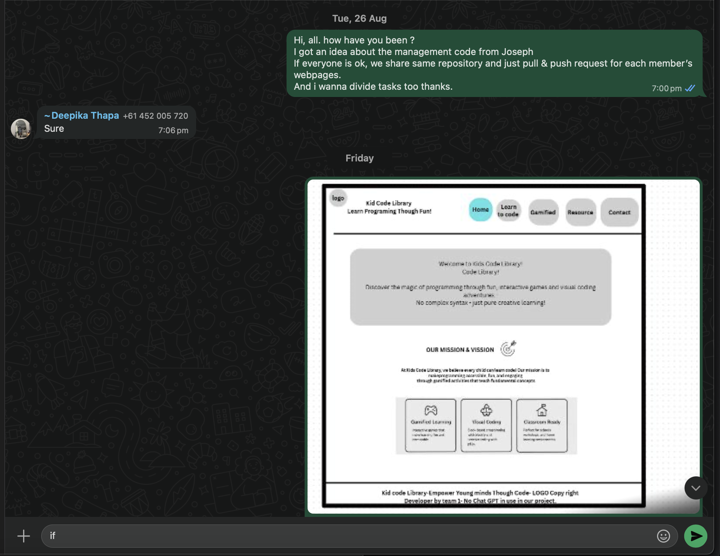

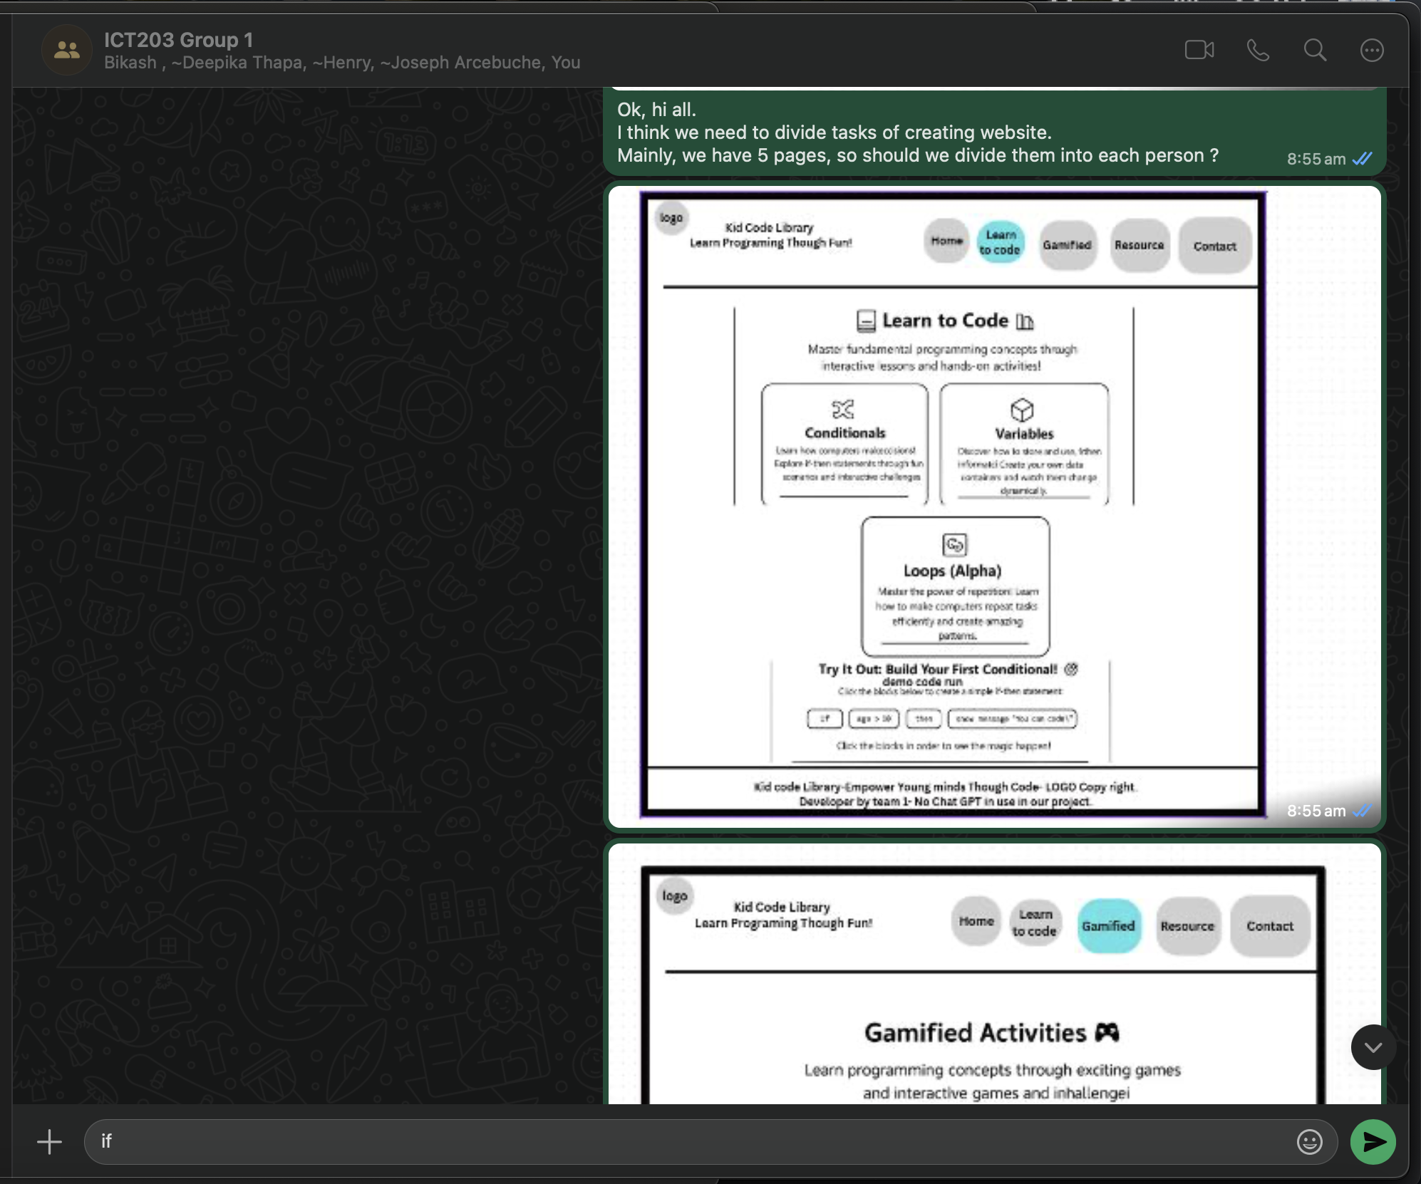

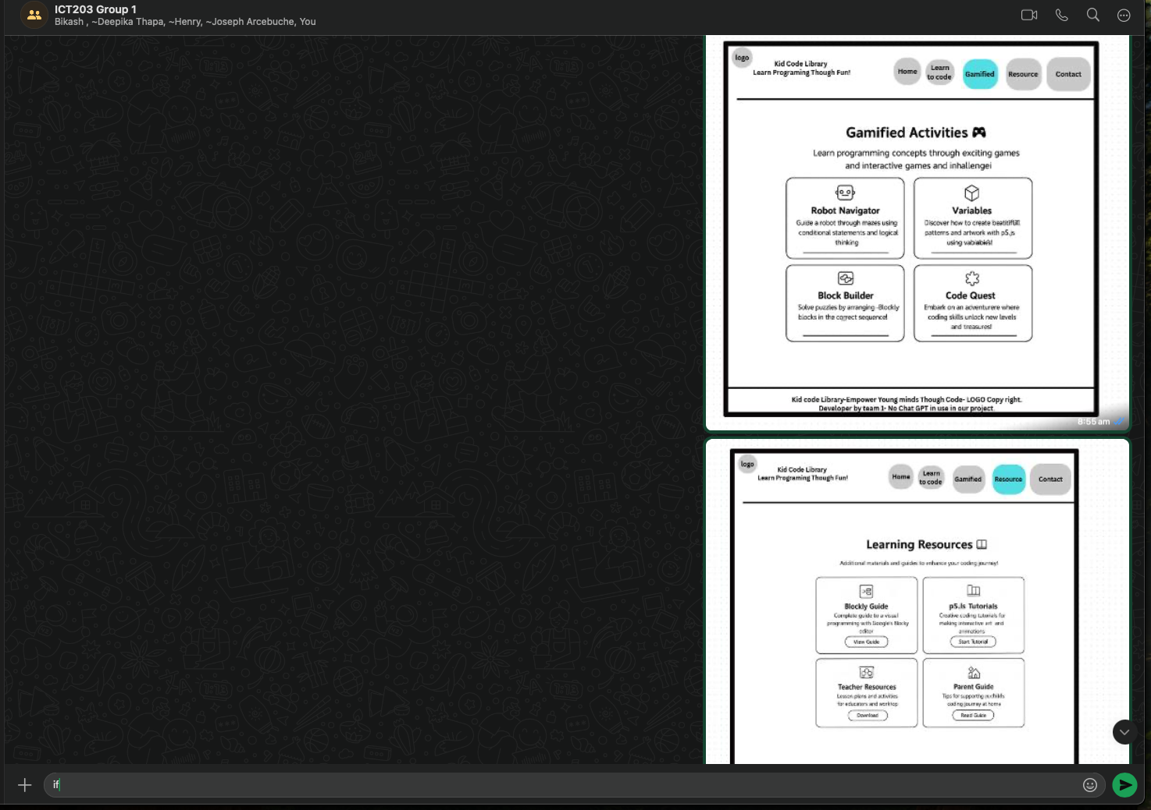

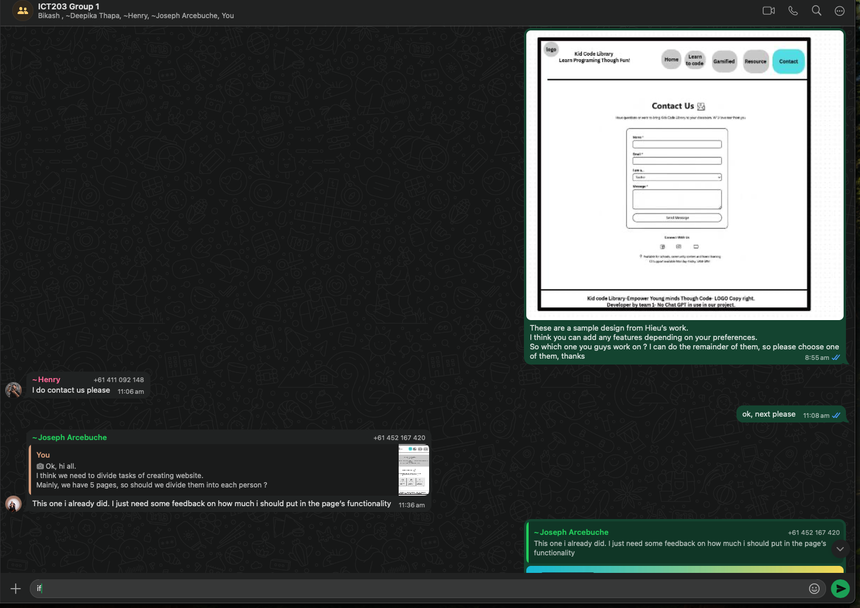

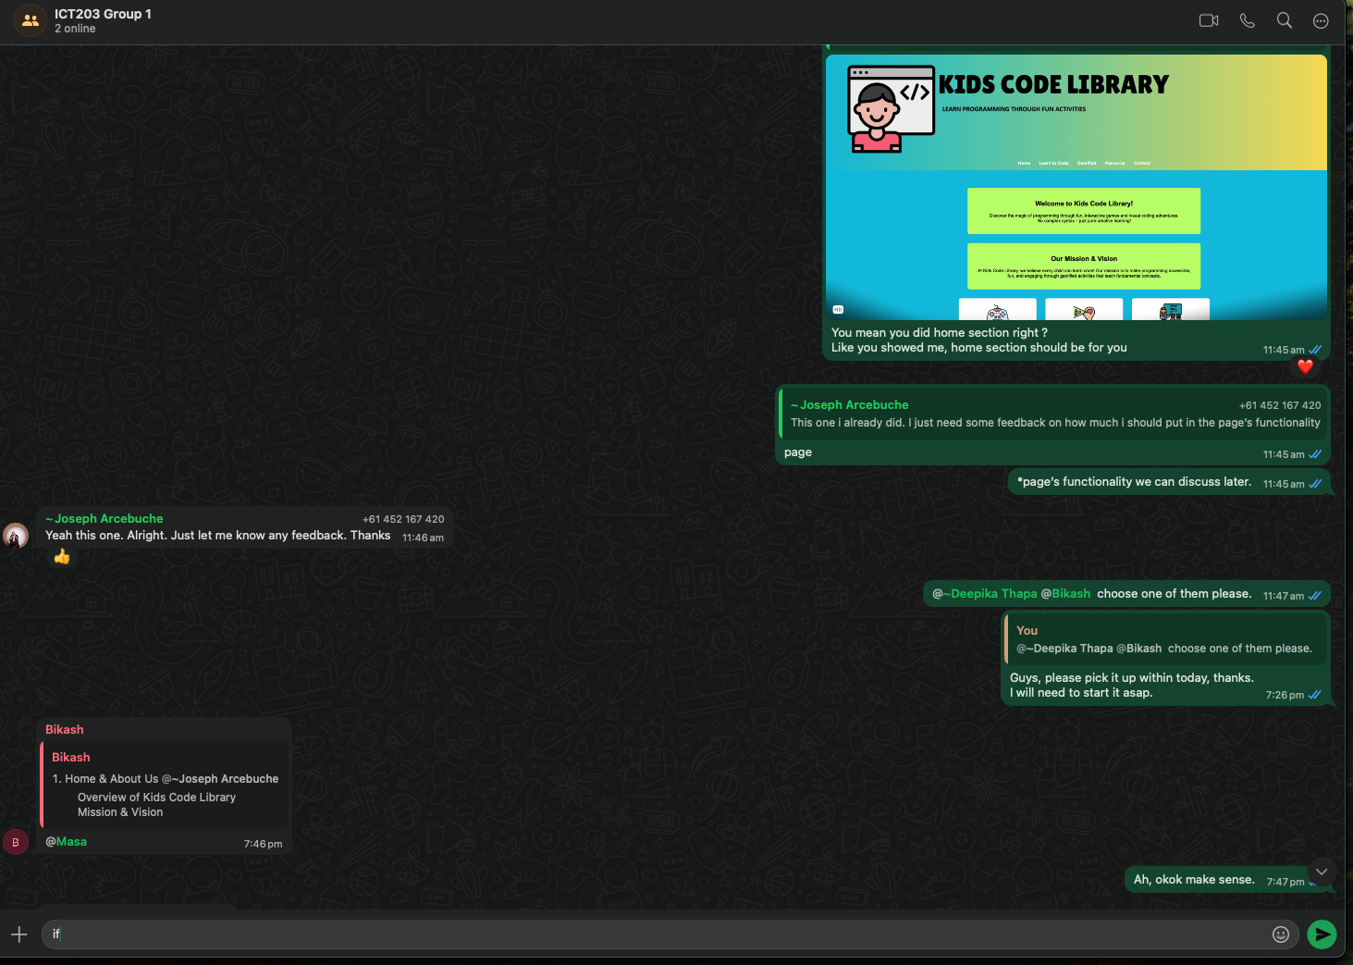

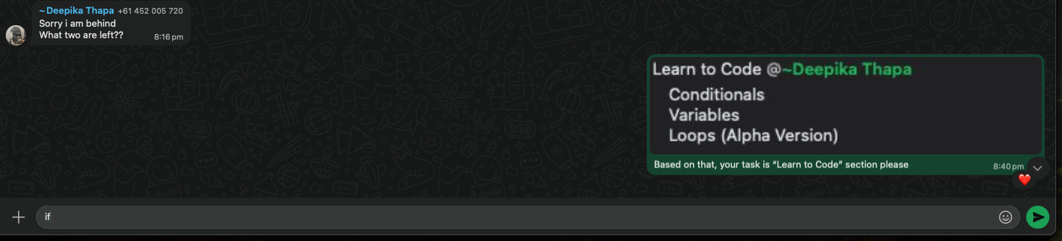

**Meeting 2**

|  |  |
| --- | --- |
| **Notice of the Meeting** | Each Member should know Date and Time of the meeting quite in advance (face to face or email, WhatsApp) to be informed by the Leader of the Group |
| **Date** | 30th August 2025 |
| **Time** | 9:40 pm |
| **Duration of the group Meeting** |  |
| **Venue** | Online |
| **Facilitator** | Masahiro Togasaki |
| **Members** | 1. Masahiro Togasaki  2. Bikash JAISWAL  3. Joseph Neil Mailom Arcebuche  4. Thanh Hieu VO  5. Deepika THAPA KSHETRI |
| **Notetaker** | Masahiro |

**Agenda**

|  |  |  |  |  |
| --- | --- | --- | --- | --- |
|  |  |  |  |  |
| **No** | **Item** | **Action** | **Responsibility** | **Documents** |
| **1** | **DISCUSSION Overview** | | | |
| 1.1 Development based on “Home” | Discuss | Each Member | No |
|  |  |  |  |
|  |  |  |  |
|  |  |  |  |
|  |  |  |  |

**Discuss Contents:**

**Joseph made Home page, which is our main page. And, Masa suggested that we need to follow the design, font, and colour for an integrated design.**

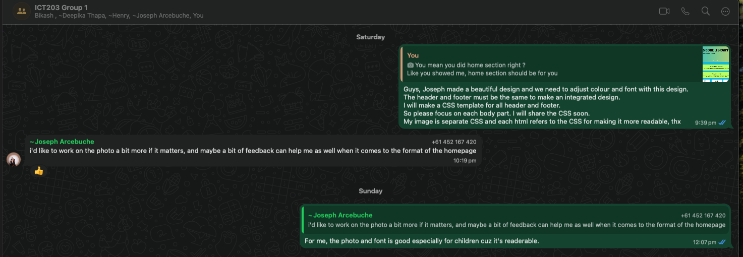

**Meeting 3**

|  |  |
| --- | --- |
| **Notice of the Meeting** | Each Member should know Date and Time of the meeting quite in advance (face to face or email, WhatsApp) to be informed by the Leader of the Group |
| **Date** | 2nd September 2025 |
| **Time** | 2:00 pm |
| **Duration of the group Meeting** |  |
| **Venue** | Online |
| **Facilitator** | Masahiro Togasaki |
| **Members** | 1. Masahiro Togasaki  2. Bikash JAISWAL  3. Joseph Neil Mailom Arcebuche  4. Thanh Hieu VO  5. Deepika THAPA KSHETRI |
| **Notetaker** | Masahiro |

**Agenda**

|  |  |  |  |  |
| --- | --- | --- | --- | --- |
|  |  |  |  |  |
| **No** | **Item** | **Action** | **Responsibility** | **Documents** |
| **1** | **DISCUSSION Overview** | | | |
| 1.1 Found an inconsistency of design | Discuss | Each Member | No |
|  |  |  |  |
|  |  |  |  |
|  |  |  |  |
|  |  |  |  |

**Discuss Contents:**

**Masa found an inconsistency of background picture of header when the using device was changed in developer mode in Google chrome (e.g. Iphone se and ipad pro). Joseph tried to find a solution, and finally, he made a picture for mobile version.**

